Meteor - PRI and SIP trunking

PRI or SIP
Traditionally, most business have been using PRI’s for telephone connectivity. Until SIP, which is changing things a lot. PRI (Primary Rate Interface) and SIP (Session Initiating Protocol) are the two methods used to connect your business to a regional telephone network.
Both methods require phone system of some type, PBX (Private Branch Exchange) equipment where the interchange between your office or facility and public lines takes place. Most existing PBX and IP PBX equipment can support both PRI and SIP Trunking connections, either directly or with an adapter. This makes either an affordable option for most businesses. So what’s the difference?
When making a decision for your business, the number of users, concurrent phone calls, and scalability to match future needs are all important considerations.

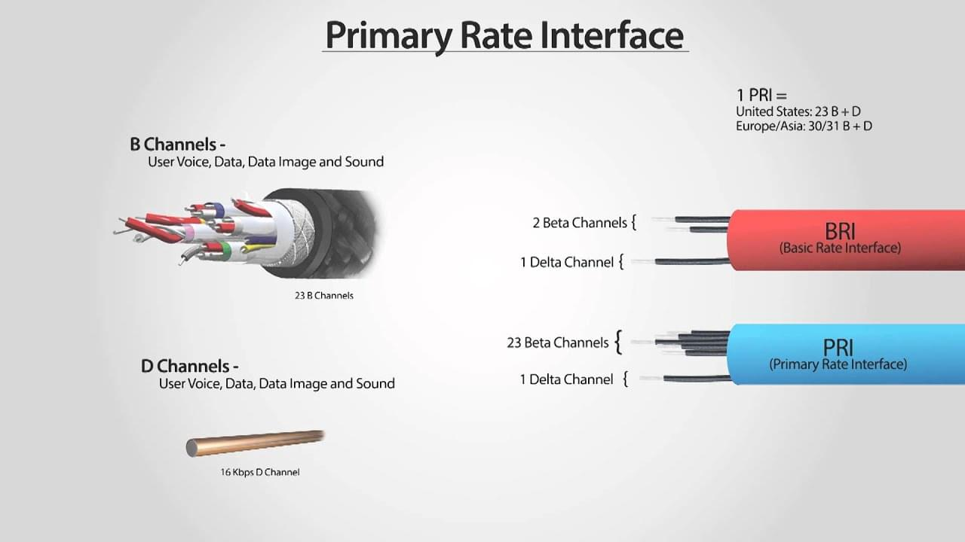
PRI TRUNKING
A PRI is a single physical connection (traditionally T1) with 23 voice channels. Now, your business can elect to have up to 100 phone numbers on a single PRI, but that single PRI can only handle 23 simultaneous phone conversations. PRI is a voice-only connection dedicated to phone transmission. Where PRI may have disadvantages for optimal scalability it stands as a higher quality voice option than voice-over-IP options.

Some pros of PRI
- Does not rely on data bandwidth to support voice calls
- High quality via dedicated line structure
- Can be made redundant via the addition of a second PRI circuit for failover

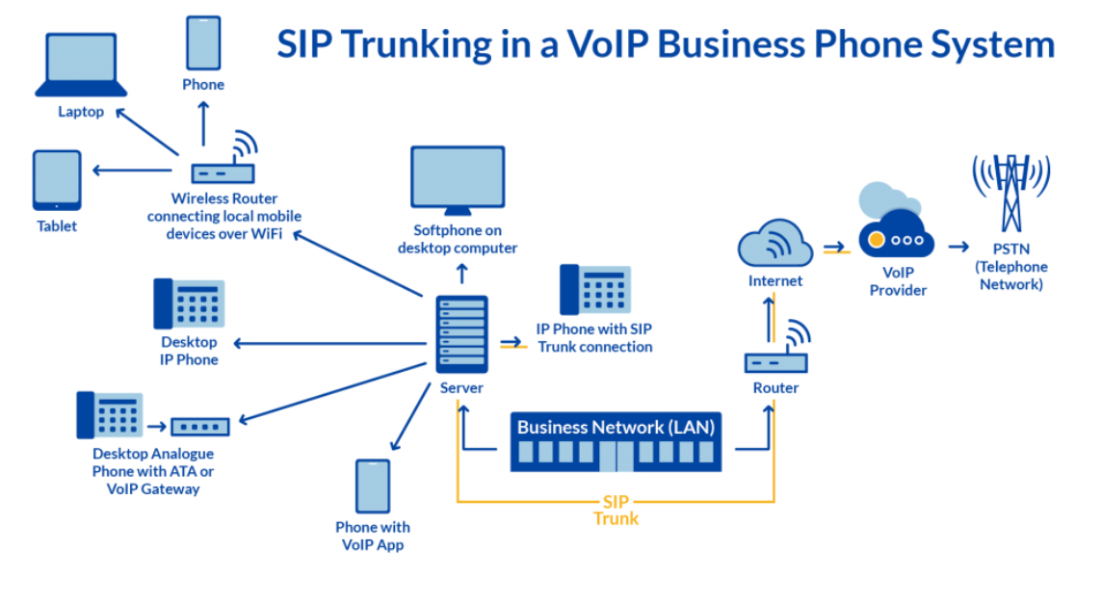
SIP TRUNKING
SIP enables businesses to use your existing Ethernet/fiber connection as a voice solution. Called VoIP (Voice over Internet Protocol), SIP connects your existing PBX interchange to a data network. This virtual connection uses a packet switched model to connect voice to voice, from phone to data connection to your regional phone lines. Flexibility is key here. This is one of the areas where SIP is the clear winner. Remember that a PRI line comes with 23 voice channels. So you can have 23 simultaneous conversations within the company. What if you need more, say 27? Well, you have to buy another PRI line that gives you 46 channels. You pay for an extra line even though you only need 4 extra channels.

PRI isn’t very flexible. It takes time to scale. Suppose you’re in the middle of your annual contract and fired a dozen employees. You don’t need 2 PRI lines anymore. Too bad, you’re stuck paying for them until the end of the year!
SIP providers allow businesses to add SIP trunks with an online request. If you use hosted VoIP, you may need to change the subscription plan to allow for more users. If your business downsizes for some reason, you can remove lines as well. You don’t have to wait for a contract to expire or even the end of the month!
Which one is better for your business boils down to what you have and need. If you have in house experts and don’t have access to high-speed internet, then PRI is suitable. But for most companies, SIP will end up as the best option for scale, flexibility, features, and not to forget, cost!

Pros of SIP Trunking
- Sold by vendors on a per-channel basis on-demand, so you only pay for the capacity needed.
- Much cheaper; cost savings vary but can be as much as 30-40% cheaper than PRI phones
- Offers failover to mobile phones in case of loss of office data connectivity
- Includes easy-to-use administrative portals for easy management
- May be offered via the cloud as part of a Unified Communications (UC) implementation
- Can be integrated with multimedia communications for collaboration and productivity
- Offers simple support for multiple sites and remote workers
- May include rich mobile features and mobile-first design
- Integrates with PRI phone lines for hybrid phone systems

